Opening the sluices of the Haringvliet, a stream of possibilities

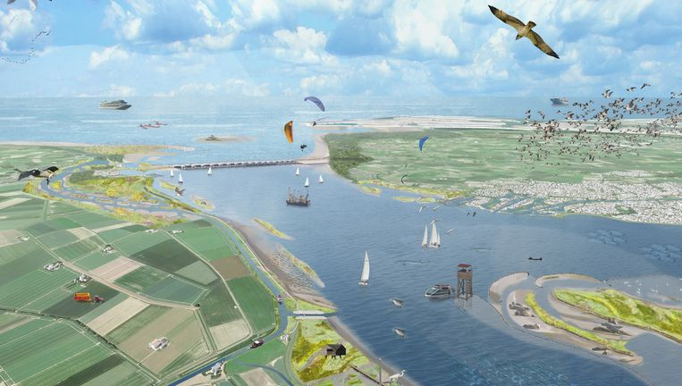
Comprehensive plan Delta21: Consequences and benefits of reintroducing tide and salt water in the Haringvliet for nature restoration.

ACT Team 2593
Valesca Baas
Nuan Clabbers
Jelle Moens
Emiel Schuurke
Jeroen Spierings
Erwin Termaat
Anne Wolma

Commissioner
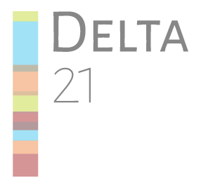
Delta21 - opening the sluices of the Haringvliet is part of their project proposal concerning the realisation of Delta21. Members are: Huub Lavooij and Leen Berke.

November, 2020

Contact details:

From the commissioners of Delta21
Leen Berke
l.berke@delta21.nl

Huub Lavooij
h.lavooij@delta21.nl

From the ACT-team:
Secretary Nuan Clabbers
nuan.clabbers@wur.nl
+316 21818719

External communications member Emiel Schuurke:
emiel.schuurke@wur.nl
+316 30504791

Source cover page illustration: Volkskrant

Executive summary
The project will provide an academic consultancy report and a presentation containing a possible solution for creating a stable brackish habitat that is functional for migratory fish in the Haringvliet without impairing freshwater provision in the delta. The commissioner of the project is Delta21 who has set up a plan that supports flood risk management and energy transition by creating an artificial lake on the North Sea side of the sluice and aims to restore nature in the Haringvliet through the permanent opening of the sluices. Our team will focus on the ecological aspects of this restoration initiative.
A preliminary study on current approaches will be performed with the aim to provide an alternative to the permanent opening of the sluices. The potential of different designs to create a stable brackish habitat will be discussed, as well as the consequences to the ecological function of, and salinization in the Haringvliet. The findings of the literature study will be discussed with relevant stakeholders by means of interviews, which will contribute to the feasibility of the design.
Our scientific backgrounds lie mainly in ecology, hydrology and marine resource management. These three expertises are exceptionally well suited to produce an alternative solution to provide a stable brackish habitat in the Haringvliet.
No costs were included in the budget due to online limitations. We scheduled 205 hours to work on the project and we will finish the project by the 11th of December.

Table of Contents

Contents
Contact details: 3
Executive summary 4
Table of Contents 5
Project description 6
Context & multi-perspective problem analysis 6
Project specific problem definition and stakeholders 8
Integrative project purpose and research questions 9
Outputs 11
Activities and research methods 11
Project management 12
Our team 12
Communication 12
Planning 14
Budget 14
References 15
Appendices 16
Stakeholders 16
Logical framework 17
Budget form 20

Project description

Context & multi-perspective problem analysis
Efficient protection from flooding of rivers, the sea and lakes is an important and ongoing task in the Netherlands. The current coastal protection will not suffice in the future due to the changing environmental factors caused by climate change, including the rising sea levels, increased variability in rainfall and temperature. The Dutch government would like to expand its current flood risk management and has multiple requirements for this future approach, including water safety; availability of freshwater supply and a spatial design of the Dutch landscape that is climate-change resilient (Ministry of Infrastructure and Water Management et al., 2020). Several plans and projects have been proposed to include these requirements in a future approach in areas throughout the country.

Within the Delta-Programme of 2020 it is stated that the Ministry of Infrastructure and Water Management, the Ministry of Agriculture, Nature and Food Quality and the Ministry of the Interior and Kingdom Relations are striving to reach a climate-resilient, safe, ecologically resilient and economically vital South-Western Delta. Effective measures are needed in order to achieve such a delta and this demands exploration of alternatives for the long run that are aimed towards safety, freshwater availability, nature conservation/restoration and economy. In the next 5 years research is needed to find possible kinks and effects of continuation of the current preferential strategy (Ministry of Infrastructure and Water Management et al., 2020). Our commissioner is Delta21, which is one of the proposed projects for the South-Western Delta. They would like to propose their project to the government as the most ideal and “typical Dutch” solution. Their plan - designed to deal with this environmental issue - combines flood risk management, energy transition and nature restoration.

Delta21 proposes to use sections in the northern part of this area in a productive way to mitigate concerns in these three major fields, by creating an artificial lake for energy storage, or an energy storage basin (Figure 1). For flood risk management the plan aims to pump away excess water from behind the dykes, which is a cheaper alternative with less impact on the unique river landscape than reinforcing the dykes. Secondly, the large pump capacity of the artificial lake can store large amounts of energy. To illustrate: it can generate about 1860 MW of energy during 12 hours (Berke et al., 2020; Berke & Lavooij, 2019). Since most of the energy in the Netherlands should be won by renewable energy sources and the CO2-production should be down by 49% according to the National Climate Agreement by 2030 (Rijksoverheid, 2019), Delta21 would like to execute their project as soon as possible in order to contribute to this goal. Lastly, integration of the Delta21 concept with the Haringvliet insists on a permanent opening of the sluices. This would allow the return of salt water and tides in the estuary, creating a brackish habitat that enables fish to migrate land-inwards. This in turn would help populations of herring, eel and sturgeon to recover in the delta, but might have negative consequences on freshwater supplies and/or quality in the Haringvliet.
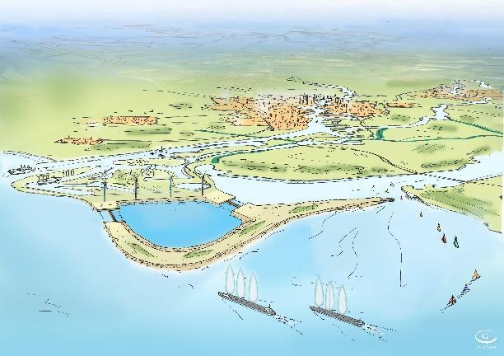
(Figure 1: concept-art of the lake that will be created by the Delta21 project at the Haringvliet. Delta21, actualisering van het plan. 2019)

The area surrounding the Haringvliet is used by multiple stakeholders, including farmers and drinking water companies. These two stakeholders depend on a safe freshwater supply and are challenged by saltwater intrusion. Nature groups participate in the debate regarding the opening of the sluices as well since the wildlife and flora in the area will be affected. The Ministry of Infrastructure and Water Management and the Ministry of Economic Affairs decide which project will be realized for the South-Western Delta and have a final say in the timeframe. The different needs and preferences for the area in combination with a knowledge gap surrounding the consequences of salinization on freshwater supplies and on the ecology of the Haringvliet hampers the finalization of any solution to the above-listed situation.

With our project we aim to review 3 different, currently proposed scenarios (sluices left ajar, 80% open and completely open) for the Haringvliet that may provide insights in alternative ways of creating a system that positively influences biodiversity and ecology without negatively influencing certain sectors like agriculture, shipping and potable water supply. Our project is necessary as we suspect that the current water management in the Haringvliet does not allow for migratory fish to successfully migrate land-inwards. Our academic research will help create an overview of 4 possibilities regarding the management of the Haringvliet including an alternative solution. This will broaden our commissioner’s scientific perspective of the ecological and hydrological state of the Haringvliet in addition to the best fitting solution for restoring nature by creating a stable brackish habitat which stimulates fish migration. We believe that with our mix of biological, hydrological and chemical backgrounds we will be able to paint a clear picture of the consequences for the area in terms of local ecosystems and stakeholders. We will be able to create an alternative solution that might provide insights regarding the feasibility of their current restoration approach.

Project specific problem definition and stakeholders
There are conflicting opinions and interests surrounding the current state of (the habitat and ecosystem in) the Haringvliet and the consequences of the suggested solution of permanently opening the sluices further remain limited to theory. This impedes the realisation of (and decision making process regarding) projects in the South-Western Delta, such as Delta21.

Main stakeholders that are involved in the debate around opening the Haringvliet are among others sectors involved with nature conservation, agriculture or potable water. A clear opposition in interest is characterised by groups wanting to introduce tidal flow and salt water to solve the undesirable state in the Haringvliet (based upon nature values/restoration) on the one hand and groups wanting to protect freshwater availability on the other hand.

Groups related to nature conservation and ecology are generally in favour of compensating the loss of Natura2000 area by boosting an estuarine ecosystem in the Haringvliet area. For some parties, such as WWF, it is desirable to realise this by opening the Haringvliet sluices and introducing tidal flow and salt water into the Haringvliet, since it is expected that this will promote biodiversity and resilience related to brackish ecosystems. However, there is not necessarily consensus within the discipline of ecology. Advisory group Borm & Huijgens for instance has its reservations about the beneficial effect of opening the Haringvliet sluice on a potential estuarine ecosystem.

In addition, important stakeholders consist of groups that have an interest in the protection of freshwater reserves. By opening the Haringvliet salt water is expected to reach further inland which is of concern to the interests of stakeholders, such as agricultural production and drinking water supply. Among this group are the two water boards Hollandse Delta and Scheldestromen, drinking water company Evides, the Ministry of Infrastructure and Water Management, the Delta Commissioner, Rijkswaterstaat, municipalities and farmers. As most of these parties are involved with Dutch policy making, they are expected to have quite some leverage in the decision making on opening the Haringvliet sluice.

A long list containing an overview of stakeholders related to the project can be consulted in the Appendix. Furthermore a stakeholder diagram is included (Figure 2):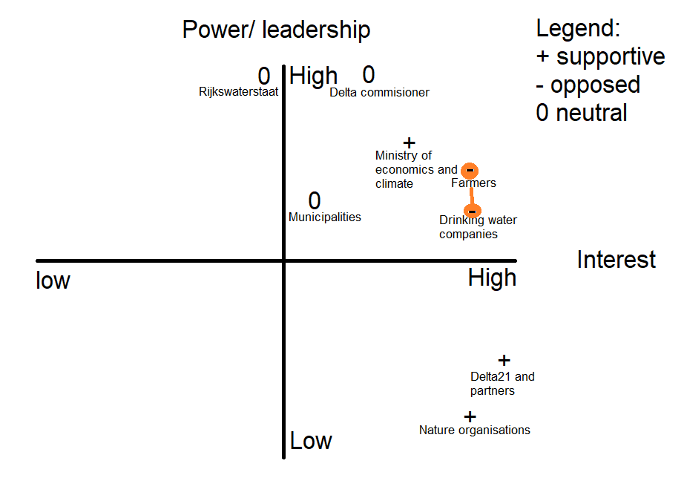
Figure 2: Stakeholder power-interest diagram including the main players
Integrative project purpose and research questions
We aim to develop a plan to create a healthy and stable brackish habitat within the Haringvliet estuary, where nature can be partly restored to its historic conditions, with an open connection to the North Sea that allows migratory fish to spawn land-inwards and return to the sea without obstacles. In addition, freshwater supply should be maintained, mainly for agriculture and potable water. This plan will be supported by first mapping the current state of the front delta of the Haringvliet and two other possible scenarios where the sluices are partially opened (80% open) or completely opened (subjected to future climate prospects), resulting in different levels of salinization. Existing brackish estuaries in the Netherlands and other countries provide inspiration for our plan. Using this information, a proposal with an alternative for brackish habitat restoration will be constructed. The most important consequences for the main stakeholders (mainly those who are directly exposed to the changes and consequences of a permanently opened Haringvliet sluice opening) will be taken into account.

In order to address the aforementioned knowledge gap, we will answer the following main research question:

What are possible solutions for creating a for migratory fish functional and stable brackish habitat within the Haringvliet, without impairing freshwater provisioning in the delta?

Sub questions supporting the main research question are as follows:
- What are requirements for successful fish migration in the Haringvliet?
- What are requirements for maintaining a safe freshwater supply?
- What could be an alternative design for permanently opening 100% or part of the Haringvliet sluices in order to provide stable brackish water habitat while safeguarding fish migration and the desired freshwater supply?
- What could be the consequences of this design for salinization during periods of low river flows or very high river flows in the Haringvliet area?
- What could be the profit for ecological functions for the adjacent river banks and the nearby region on the North Sea side of the sluice?

We strive to indicate the pros and cons of these 4 different scenarios for the main stakeholders, based on existing knowledge in literature. This will create an overview of possible effects that will support Delta21 in the debate surrounding the opening of the sluices.
Our purpose is to speak with at least 3 stakeholders, who are directly involved with the project. The goal of these conversations is to gather more perspectives in this project and to collect possible additional information, concerns and ideas. Since a lot of projects and research have already been conducted in the area, these conversations will mostly take place once we have collected sufficient background information about the current situation and are in need of additional information or feedback.

We have to take precaution with regards to voiced opinions and perspectives of stakeholders between them and other stakeholders. Our aim is to gather information that would support our research with the help of opinions of the stakeholders and not to stir up conflicts between them. When opinions on other stakeholders are given in confidentiality it is not up to us to share this with the concerned stakeholder. When approaching stakeholders we will properly inform them in advance about the purpose of our project and be transparent about the use of the provided information. We will also perform our own literature research to make sure that we have the knowledge to make a proper assessment on the topic and have insight into the consequences and causes underlying the project.

Outputs
We will provide an academic consultancy report for Delta21 in which we will divulge possible solutions for creating a stable brackish habitat in the Haringvliet which is functional for migratory fish and does not impair freshwater provisioning in the delta. We will create this report based on our broad, combined expertise including ecology and hydrology.
Therefore, we will review 4 different scenarios that we will base on literature by discussing potential designs of a partially or completely opened Haringvliet. The hydrological consequences concerning river flow, tides and salt water intrusion levels will be worked on by our hydrological experts. Our ecological experts will discuss the ecological benefits that are created by a stable brackish habitat. Stakeholders will be interviewed, in these interviews we will gather information and discuss potential solutions. The polling of the opinions of different stakeholders will give a more clear overview of the path forward in the discussion surrounding the Haringvliet. Next if the opportunity presents itself, we would also like to interview people from different projects that have a similar purpose like ours, however, this is not a requirement.
When the report is finished a summarizing powerpoint presentation will be created and will be presented to our commissioner, Delta21.

Activities and research methods
We will start with a literature study, by gathering relevant information on research databases like Google Scholar and the library from Wageningen University and Research. The contributing papers will be directed to our private group in Mendeley, so that parallel research is more easily conducted. This will be followed by interviews with relevant stakeholders to obtain information and poll their opinions.
The literature study will be conducted into existing literature about 3 different scenarios regarding the Haringvliet sluices. Furthermore we will look into existing alternatives for open sluices in deltas around the world. Based on the literature study we will be able to provide answers to our subquestions. So, once the literature study is finished, we will have an idea of what designs for a permanently open Haringvliet could be implemented with minimal consequences for the fresh water provision in the area. The literature study contains relatively low risks in terms of performance issues. The only difficulties we can expect is missing or contradicting literature.
The interviews will be performed at the end phase of our literature study. This is done so that we can gather any additional information we would need to answer our subquestions. But, perhaps most importantly we will gather the opinions of the main stakeholders in the area to weigh the feasibility of the design we propose. For the interviews there is a higher risk involved. Stakeholders may refuse to speak to us or not have time to speak to us. This may hamper our research progress. We will try to mitigate this risk by providing an objective question to the stakeholders and clearly state that we are open to their input. The exact nature of our research plan is included in our logical framework in the appendices.

Project management

Our team
Our team consists of 7 master students from varying studies at the Wageningen University. Our specialties lie in ecology, hydrology, chemistry, conservation, management and biology. Each individual team member has their own set of skills so each member will be introduced with their respective skill set and how they complement each other.

Emiel Schuurke is studying the master Earth and Environment and is currently specializing in the biology and chemistry of soil and water. He is good at compactly and clearly summarizing large amounts of information. Next we have Nuan Clabbers, our secretary, she is also studying Earth and Environment. Her specialisation on hydrology and water resources. She is good at taking minutes and planning. Valesca Baas is studying Biology and is specializing in ecology and biodiversity. She is also a team worker out of nature and is thus capable of keeping the teamwork fun and enjoyable. Our next team member is Erwin Termaat. He is studying Aquaculture and Marine Resource Management and is specializing in aquaculture, next to this he has experience in agriculture and fishery management. Jelle Moens is also studying Aquaculture and Marine Resource Management and is also specialized in aquaculture. Next to this he also has expertise on marine ecology and is a team worker, thus keeping the team together. Next we have Anne Wolma, our manager. She is studying the master Forest and Nature Conservation and the master Aquaculture and Marine Resource Management. Within these masters she focuses on management, conservation and ecology. Next to this she is very skilled in the management of the team and makes sure that everybody knows what they have got to do and that they finish this in time. Last but not least we have Jeroen Spierings. He studies Biology and has a specific focus on marine biology and ecology. He is very creative with ideas and therefore, he can bring original solutions to problems that arise. Since our project focuses on the hydrology, ecology and chemical state of the Haringvliet we believe that we have the perfect skills set to tackle this project and provide a clear and concise consult that can aid Delta21 in further goals.

Communication
Within the team we assigned several people with specific communication tasks:
- Manager - Anne Wolma
Responsible for the overview of internal communication; agenda for meetings and goals for the day / week. Responsible for hosting meetings both with the team as with external parties. Communicates on a daily basis with team members.
- Secretary - Nuan Clabbers
Responsible for writing the minutes of meetings. Responsible for distributing the minutes to all parties involved in the meetings, within 48 hours of that meeting.
- Schedule coordinators - Nuan Clabbers and Jelle Moens
Responsible for maintaining the schedule of the project, including the (major/interfering) personal activities of team members.
- External communication - Emiel Schuurke
Responsible for the communication with external parties as the academic advisor and commissioners. Communicates whenever significant questions arise, progress is made and a meeting is requested.

Commissioners: Huub Lavooij and Leen Berke from Delta21, from now on referred to as Delta21.
ACT coach: Lian Kasper.

Agreements and arrangements with commissioners
Delta21 is contacted whenever significant questions arise or progress is made and a meeting is requested. Delta21 has agreed to provide information needed for the functioning of our project, but pointed out that the project-information is publicly available. Delta21 agreed to provide feedback (either written/oral) as soon as it is possible in their schedule.
Intermediary deadlines from (draft/end) products have not been established with Delta21 yet, but will be according to the ACT-schedule.

Information sharing & restrictions
The information provided by Delta21 concerning their project are non-confidential and can be found on their website. Discretion is asked from the team concerning stakeholder-meetings and stakeholder-informatio

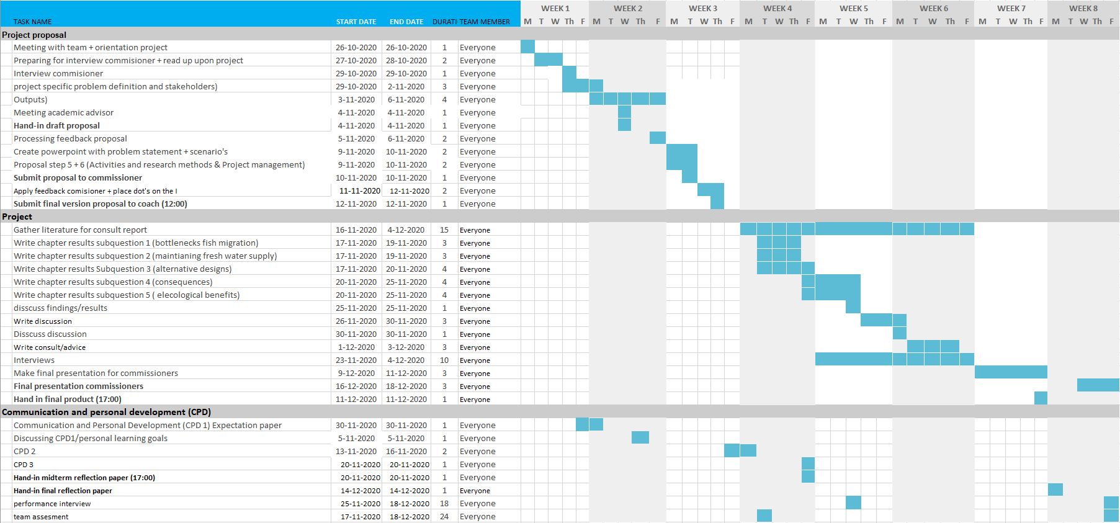
Planning

Budget
Due to the current situation because of corona and limitations that are created by this, there are no foreseeable cost items for which a budget is needed. Therefore we have excluded a budget for our proposal.

References

- Berke, L., & Lavooij, H. (2019). Update 2019: DELTA21 Een actualisering van het plan. https://www.delta21.nl/wp-content/uploads/2019/09/UPDATE-DELTA21-29-7-2019.pdf
- Berke, L., Lavooij, H., Brühl, C., Helsen, G., Van Kempen, G., Kivits, D., & Van Toorn, M. (2020). Connecting Delta21 to its stakeholders: The Haringvliet case 5th of June 2020 Commissioned by Delta21.
- Ministry of Infrastructure and Water Management, Ministry of Agriculture, Nature and Food Quality and Ministry of the Interior and Kingdom Relations (2020). Deltaprogramma 2020: Doorwerken aan de delta: nuchter, alert en voorbereid.
- Rijksoverheid. (2019). Klimaatakkoord. Klimaatakkoord, 250. https://www.klimaatakkoord.nl/binaries/klimaatakkoord/documenten/publicaties/2019/06/28/klimaatakkoord/klimaatakkoord.pdf

Appendices

Stakeholders
- Delta21 and their partners
  - Delta21 wants to realize their project in the delta
- Farmers
  - The farmers work the areas around the Haringvliet. They want to keep a freshwater basin in the Haringvliet to prevent saltwater intrusion and have access to a freshwater basin.
- Aquaculture
  - Organisations and individuals that want to perform aquaculture (growing molluscs for example).
- Municipalities
  - The municipalities that surround the Haringvliet and will be directly impacted by changing it.
- Nature organisations
  - Organisations like WWF and all have their interests in the Haringvliet.
- Natura2000
  - European network of protected nature areas.
- Foundation the Noordzee
  - Nature organisation regarding the north sea itself. Which will also be impacted by an open Haringvliet.
- Water boards Hollandse Delta and Scheldestromen
  - The water boards that manage the areas that are impacted by an opening of the Haringvliet sluices.
- Drinking water company evides
  - The drinking water company that currently works at the Haringvliet area. They want to prevent salt water intrusions into their drinking water winning areas.
- Local inhabitants
  - Although they might have less of a voice if they unite they may be able to push their agendas.
- Fisheries
  - The fisheries that work the Haringvliet and sea delta.
- Ministry of economics and climate
  - The Dutch ministry of economics and climate works on a sustainable and enterprising society.
- Ministry of infrastructure and water management
  - The ministry that is responsible for the water management and will thus directly be involved in the Haringvliet.
- Delta commissioner
  - The overseer regarding the entirety of the delta works. As the Haringvliet is part of that the delta commissioner is directly involved in the decision making.
- Rijkswaterstaat
  - The executive part of the ministry of infrastructure and water management.

Logical framework
 | Summary | Indicators | Evidence | Assumptions
Commissioner’s goal | Realize and execute the Delta21 project
Team’s purpose | Provide an insight in the effects of opening the Haringvliet sluices (in different scenarios) and provide alternative solutions for creating a stable brackish habitat whilst safeguarding freshwater supplies in the Haringvliet.
Output | An academic consultancy report and powerpoint presentation containing:  - What are requirements for successful fish migration in the Haringvliet?  - What are requirements for maintaining a safe freshwater supply?  - What could be an alternative design for permanently opening 100% or part of the Haringvliet sluices in order to provide stable brackish water habitat while safeguarding fish migration and the desired freshwater supply?  - What could be the consequences of this design for salinization during periods of low river flows or very high river flows in the Haringvliet area?  - What could be the profit for ecological functions for the adjacent river banks and the nearby region on the North Sea side of the sluice? | - Finished draft with answers to output and sent to commissioner  - Finished consultancy report (11-12-2020)  - Presentations with outputs to the commissioner | - Draft of consultancy report sent to coach and eventually commissioner.  - Final consultancy (Brightspace, 11-12-2020, 17:00)  - Draft presentation (Google Drive)  - Handed in (Brightspace) | Provide an alternative solution for opening the Haringvliet sluices which minimizes negative effects on stakeholders
Activities | A parallel literature study, shared amongst members in Mendeley regarding:  - Current situation in the Haringvliet  - short stakeholder analysis on the main parties and their interests  - three different scenarios in opening the Haringvliet sluices.  - Alternative solutions to creating a brackish habitat.  - in depth research into final alternative  Stakeholder interviews to get:  - information regarding the Haringvliet and to support our own findings in the literature study.  - Their opinions on alternative solutions for brackish habitat reintroduction.  Answering our (sub)questions | - Search for information regarding subquestion 1 (week 4)  -Search for relevant information regarding subquestion 2 (week 4)  -single out appropriate stakeholders (week 4)  - 3 appointments made with stakeholders(week 4)  - Questions for interviews ready (week 4)  - Search for relevant literature regarding subquestion 3 (week 4)  - Search for relevant literature regarding subquestion 4 (week 4,5)  -Search for relevant literature regarding subquestion 5 (week 4,5)  -Write subquestion 1 (week 4,5)  -Write subquestion 2 (week 4,5)  -write subquestion 3 (week 4,5)  -write subquestion 4 (week 5,6)  -write subquestion 5 (week 5,6) | - List of literature in group Mendeley  - List of appropriate stakeholders on Google Drive  -Appointments confirmed by secretary  -List of questions available (Google Drive)  - Minutes of interviews available (Google Drive)  - Answers to sub questions written out in text. (Google Drive) | We want to have at least enough relevant information obtained through our literature study before the interviews to make them relevant.  We want to interview at least 3 different stakeholders  We want to find at least three relevant articles per subject.

Budget form
Due to restrictions and working at home due to covid regulations we do not have a clear oversight on whether we will have any expenses.

